Image Grabber Module – Run Setup

1. **Pre-Requisites:** 
   * Raise request to VPN access for edge servers and install AnyConnect VPN.

[Link to VPN access request and downloading AnyConnect VPN](https://siemensgamesa.visualstudio.com/SGRE%20Digital%20Transformation/_wiki/wikis/SGRE-Digital-Transformation.wiki/1785/VPN-setup)

* + Install anaconda software and generate authentication key pairs for SSH.

Provide public key to DevOps to get added to edge servers, required to get access to edge servers for the machine.

* + - [Link to download anaconda](https://docs.anaconda.com/anaconda/install/windows/).
    - Generating SSH key pairs.
      * Open anaconda prompt and install [OpenSSH](https://anaconda.org/conda-forge/openssh).
      * Run command ssh-keygen , keep the values default (press enter every time).

It will generate public-private key pair and will save it your system under users > .ssh folder.

Example - C:\Users\abhishek.jha@siemensgamesa.com\.ssh.

* + - * Provide public key to DevOps team to get added to edge server.
  + Install [docker desktop tool](https://docs.docker.com/docker-for-windows/install/).
  + Install VS Code and certain plugins for easy usage.

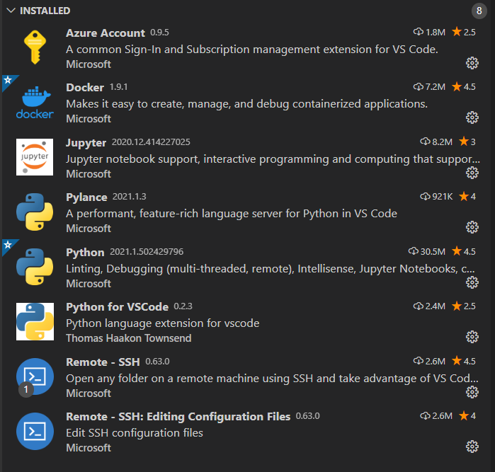

**Note: You must have access to azure resource group** - RGDEVDVLGENOBAWE01, Subscription "SGRE DEV DVL GEN WE01 - CSP"

**Setup Process**:

1. Git Clone repository. <https://dev.azure.com/SGRE-IBM/BladeInspection/_git/blade-inspection-wiki>
2. Go to command line > try docker command to check if docker is installed.

(try executing below commands –

Docker – shows if docker is installed.

Docker PS – shows process / running containers.

Docker Images – Installed Docker Images.

)

1. Run below command >

Mounts repo to docker scripts folder> mounts the SSH key folder> installs azure cli> opens bin bash

|  |
| --- |
| **docker run -it -vC:\SGRE\KT:/scripts -vC:\Users\Z0045NYE\.ssh:/root/.ssh mcr.microsoft.com/azure-cli bin/bash**  **C:\SGRE\KT** – path where blade inspection wiki is cloned.  **C:\Users\Z0045NYE\.ssh** – path where ssh keys are present, generally inside your user folder\.ssh |

The above command mounts the cloned code to scripts for availability to docker container.

Also mounts the .ssh to access the edge server in container.

And opens bin bash to run commands.

1. Run command **“az login”** to login to azure portal in the docker bin bash. Use the l2 admin credentials to login to azure portal to access the resource group.
2. Below is the directory structure where you can find the camera start/ stop shell scripts.

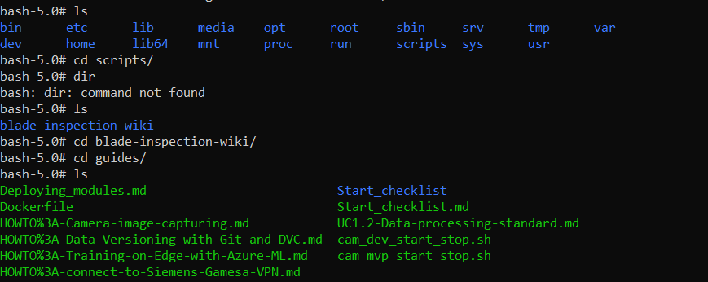

1. You can run the commands in bin bash to start stop camera (shell scripts).
2. Also, you can connect to edge server through anaconda prompt after connecting to VPN and.
3. Another way to connect to edge server is trough remote ssh in visual studio code, which can show the images grabbed from the module.

Certain useful commands.

nload – to check the network load on edge server.